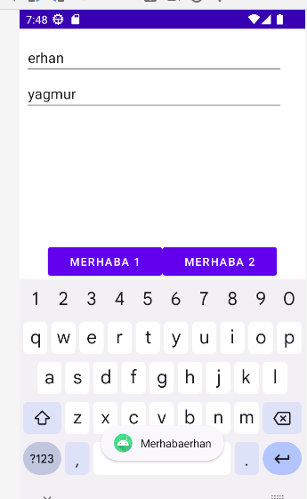

|  |
| --- |
| *<?***xml version="1.0" encoding="utf-8"***?>* <**androidx.constraintlayout.widget.ConstraintLayout xmlns:android="http://schemas.android.com/apk/res/android"  xmlns:app="http://schemas.android.com/apk/res-auto"  xmlns:tools="http://schemas.android.com/tools"  android:layout_width="match_parent"  android:layout_height="match_parent"  tools:context=".MainActivity"**>   <**LinearLayout  android:id="@+id/linearLayout"  android:layout_width="326dp"  android:layout_height="238dp"  android:orientation="vertical"  app:layout_constraintBottom_toBottomOf="parent"  app:layout_constraintEnd_toEndOf="parent"  app:layout_constraintHorizontal_bias="0.188"  app:layout_constraintStart_toStartOf="parent"  app:layout_constraintTop_toTopOf="parent"  app:layout_constraintVertical_bias="0.543"**>   <**EditText  android:id="@+id/txtadi"  android:layout_width="match_parent"  android:layout_height="wrap_content"  android:ems="10"  android:hint="Ad"  android:inputType="textPersonName"** />   <**EditText  android:id="@+id/txtsoyadi"  android:layout_width="match_parent"  android:layout_height="wrap_content"  android:ems="10"  android:hint="Soyad"  android:inputType="textPersonName"** />  </**LinearLayout**>   <**LinearLayout  android:layout_width="289dp"  android:layout_height="101dp"  android:orientation="horizontal"  app:layout_constraintBottom_toBottomOf="parent"  app:layout_constraintEnd_toEndOf="parent"  app:layout_constraintStart_toStartOf="parent"  app:layout_constraintTop_toBottomOf="@+id/linearLayout"**>   <**Button  android:id="@+id/btnmrb1"  android:layout_width="wrap_content"  android:layout_height="wrap_content"  android:layout_weight="1"  android:text="MERHABA 1"** />   <**Button  android:id="@+id/btnmrb2"  android:layout_width="wrap_content"  android:layout_height="wrap_content"  android:layout_weight="1"  android:text="MERHABA 2"** />  </**LinearLayout**> </**androidx.constraintlayout.widget.ConstraintLayout**> |

|  |
| --- |
| **package** com.example.metodkavrami;  **import** androidx.appcompat.app.AppCompatActivity;  **import** android.os.Bundle; **import** android.view.View; **import** android.widget.Button; **import** android.widget.EditText; **import** android.widget.Toast;  **public class** MainActivity **extends** AppCompatActivity { Button **mrb1**,**mrb2**; EditText **ad**,**soyad**;  @Override  **protected void** onCreate(Bundle savedInstanceState) {  **super**.onCreate(savedInstanceState);  setContentView(R.layout.***activity_main***);   **ad**=findViewById(R.id.***txtadi***);  **soyad**=findViewById(R.id.***txtsoyadi***);   **mrb1**=findViewById(R.id.***btnmrb1***);  **mrb2**=findViewById(R.id.***btnmrb2***);   **mrb1**.setOnClickListener(**new** View.OnClickListener() {  @Override  **public void** onClick(View v) {  String isim;  isim = (**ad**.getText().toString());   String yaz = selamVer(isim);  Toast.*makeText*(getApplicationContext(),yaz,Toast.***LENGTH_LONG***).show();   }  });   **mrb2**.setOnClickListener(**new** View.OnClickListener() {  @Override  **public void** onClick(View v) {  String isim,soyisim;  isim = (**ad**.getText().toString());  soyisim = (**soyad**.getText().toString());   String yaz = selamVer(isim,soyisim);  Toast.*makeText*(getApplicationContext(),yaz,Toast.***LENGTH_LONG***).show();   }  });  }  **private** String selamVer(String isim)  {  **return "Merhaba"** + isim;  }  **private** String selamVer(String isim,String soyisim)  {  **return "İyi Günler"** + isim +**" "**+soyisim;  } } |